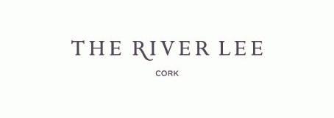

Reservation Form
Western Road, Cork City, Ireland

Reservation Form – CRIT270818
All rooms will be release on the 27th July 2019

***Bedrooms are subject to availability*****

Name: ______________________

Address: _______________________

_______________________

Telephone: ________________________Fax: ____________________

Email: _____________________________

Accommodation Requirements:

Arrival Date: _________________ No of Nights: ______ No of Pax: _____ person

Room Type Required:
Bed& Full Irish Breakfast

Superior Single room ☐ €130.00

Superior Twin room ☐ €145.00

Cancellation policy for individual rooms is 24 hours in advance

Credit Card details: ______________________ Exp date: ______________

Please return this reservation form to Colette Hurley , Reservations Agent @ The River Lee Hotel
Tel: 021 4937706

E-Mail: Colette_hurley@doylecollection.com

Fax: 021 4274477

